COURSE INFO
www.qucam.com

SCIENTIFIC DETECTORS IN THE VISIBLE AND INFRA-RED
Teacher: Dr. Simon Tulloch has worked for 20 years in observatory operations and scientific instrument development. He has built cryogenic cameras at the Isaac Newton Group, the European Southern Observatory and as a private contractor at the University Complutense.
Course Summary: The course begins with an introduction to the solid-state physics underlying the operation of modern scientific visible and near infra-red detectors. The basic principles of photo-diodes, CMOS and CCD detectors are then outlined. Visible wavelength detectors are then described in more detail. It is explained how CCD detectors have been progressively improved over the last 50 years and how their performance is now closely approaching that of an ideal detector. The current state of alternative CMOS design detectors and how they compare to CCDs is also described. Photon counting detectors such as the Electron Multiplying CCD and the Leonardo Saphira are also covered. The course then moves to longer wavelengths, covering the use of Teledyne Hawaii HxRG Near-Infra-Red (NIR) detectors and the Raytheon Aquarius Mid-Infra-Red (MIR) detectors. The various noise sources that degrade scientific observations with any detector and the way they combine statistically are examined in depth. The course finishes with a study of essential detector related topics such as characterisation, cryo-vacuum systems, thermal control and controller electronics.
At whom the course is oriented: The course is oriented at physicists, engineers and astronomers that have worked or are working in instrumental projects that involve the use of CCDs or IR imaging arrays, who feel that that they would benefit from a more in-depth knowledge of the detectors that play such a central role in the performance of their instruments. The course would also be a valuable introduction for those wishing to become scientific detector specialists.
Previous grounding: A basic grounding in physics is required. Some knowledge of electronics would be desirable but is not essential. The course contains very little mathematics.
At the end, the attendances will get:
- To gain an in-depth knowledge of the physics underlying modern scientific visible and infra-red detectors.
- An appreciation of the current advanced level of detector technology and the likely paths that further development will take in the near future.
- To be in a position to identify a suitable detector technology for their particular engineering application and to understand the various performance parameters described in manufacturers data sheets.
- A knowledge of the techniques of detector characterisation in practical camera systems.
SPECIFIC TOPICS COVERED
- Underlying Physics:
  - Semiconductors and the Periodic Table.
  - The PN junction and its sensitivity to light.
  - The electromagnetic spectrum and atmospheric transmission.
  - Understanding detector performance data.
  - Statistics of photons.

- CCDs:
  - Physical structure.
  - CCD clock sequence design.
  - Output amplifier variants.
  - Noise sources: read noise, dark current, reset noise and photon noise.
  - Boosting performance with backside illumination and thinning.
  - Deep-depletion CCDs and Fringing.
  - Anti-reflective coatings and Quantum Efficiency.
  - Hi-Rho and Bulk-silicon CCDs.
  - Electron-multiplying CCDs and their advantages/disadvantages.
  - Traps.
  - High-speed operation.
  - Low-noise preamplifiers.
  - Analogue and Digital video processor design.
  - CCD mosaics.
  - CCDs in Space.
  - ESD precautions.

- CMOS sensors:
  - Physical structure.
  - Global and Line Reset.
  - Unit cell circuitry: 3T,4T and 5T designs.
  - Boosting performance with microlenses and Silicon-on-Insulator fabrication.
  - Hybrid CMOS.

- Infra-red sensors:
  - Mercury Cadmium Tellurium as a sensor material.
  - The Teledyne HxRG detectors.
  - The Saphira detector.
  - Blocked Impurity Band detectors.
  - Fowler Sampling.
  - Persistence.
  - Subtle image defects.

- Cryo-vacuum systems:
  - The Planck curve and the need for cooling.
  - Cooling methods.
  - Thermal sensing and control.
  - Vacuum materials.
- Detector Characterisation:
  - Measuring Quantum Efficiency.
  - Measuring gain and noise.
  - Flat-fielding.
  - Use of Iron-55 X-rays.
  - Mosaic Coplanarity.

SAMPLE PRESENTATION MATERIAL
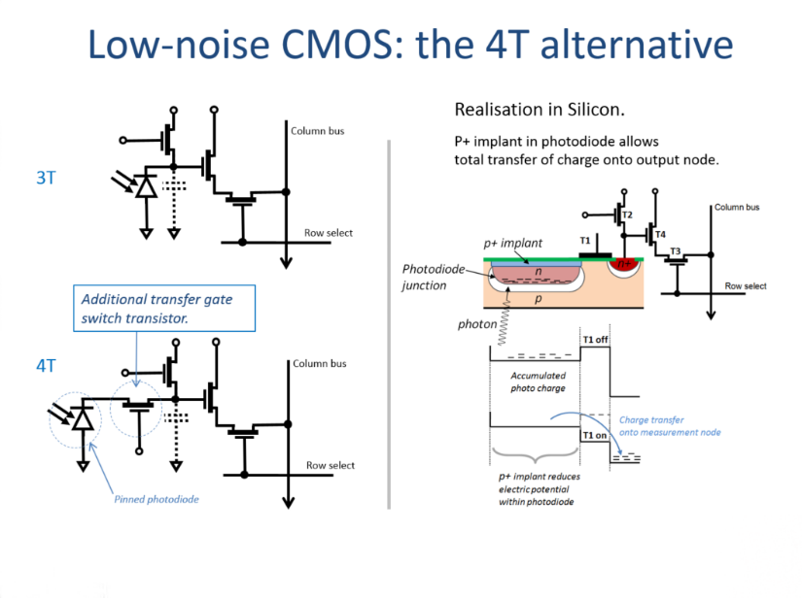
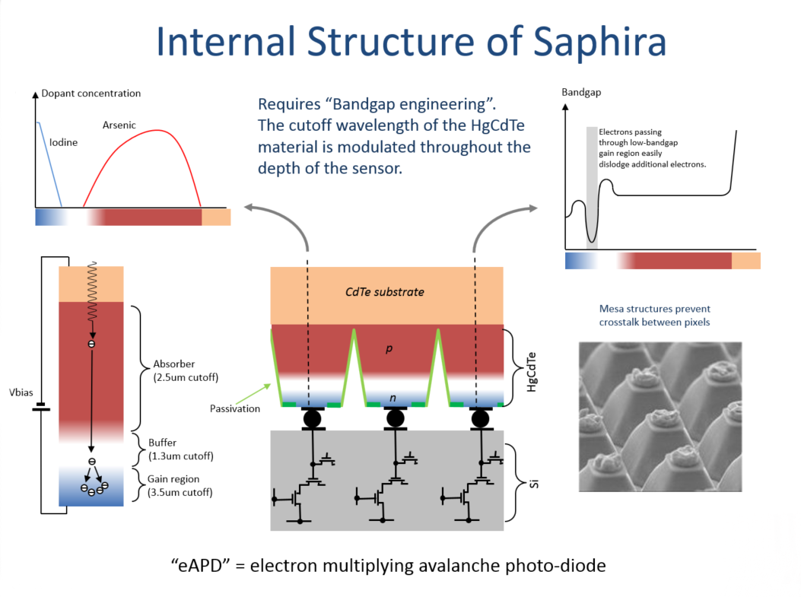

VENUE
The course is offered either on the client’s premises or in a venue 10 minutes walk from the Santa Justa train station in Sevilla, Spain. High speed AVE trains leave hourly from Madrid Puerta de Atocha, travel time to Sevilla is approximately 2h40m. Timetables are available at www.renfe.com. The venue, shown below, can seat a maximum of 8 students. The historic centre of the city is about 30 minutes walk away.
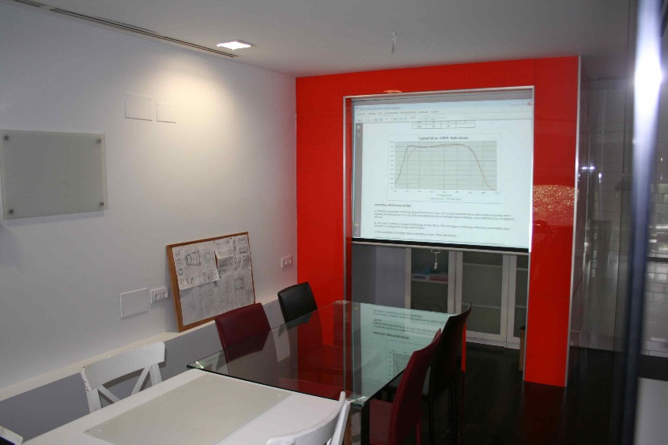

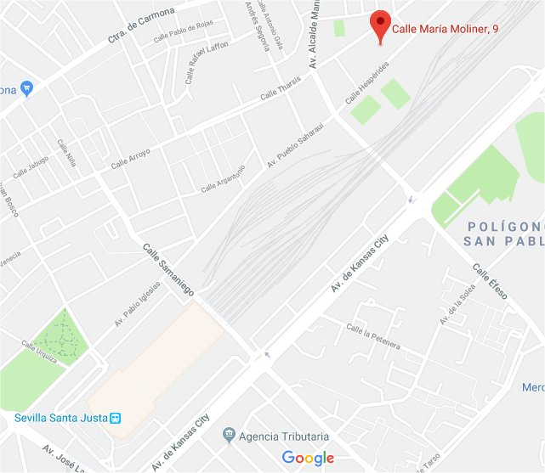
Sevilla airport has good connections to Madrid and the Canarys. Iberia, Vueling and Ryanair are the main carriers. The airport bus stops directly in Santa Justa station, travel time about 20 minutes. Jerez airport, about 90km distant, is an alternative but has poor public transport links.

COURSE FORMAT AND PRICE
The course consists of 2.5 days of power point presentations. The final afternoon will be dedicated to revision of client-requested topics. English medium will be used although the teacher is fluent in Spanish also. Each day is divided into 4 sessions with breaks for coffee and lunch. Practical demonstrations of sensor characterisation will be given with a commercial CCD camera.

Price for course held on client premises within Europe:
Per student : €850+VAT. Includes 100 page booklet of printed course material.
Minimum class size 5 students. Discounts for groups greater than 10.
Economy travel from Jerez de La Frontera to the client’s location and 4 nights accommodation will be added to the tuition fees. Exact price can be given once a formal quote is requested.

Price for course held at the Sevilla venue:
Per student : €1050+VAT. Includes 100 page booklet of printed course material. Snacks, coffee and a lunchtime buffet will be provided.
Class size between 5 and 8 students.

Course locations outside of Europe:
Please enquire for price details.

The course will be available from June 2019 onwards. Dates and times are flexible. Preferred timetable: Tuesday to Thursday, 10:00 -> 17:00. A course can be reserved with payment of a 1000€ deposit with the full balance payable prior to course commencement. The deposit is not refundable if the client decides to cancel with less than 1 months notice.

smt@qucam.com
www.qucam.com

